Ravan Muradzada
Contents
Task 1 1
Task 2 2
Task 3 3
Task 4 4
Task 5 4
Task 6 5
Task 7 6
Task 8 8
Task 9 8
Task 10 8
Task 11 9
Task 12 9

Task 1
It enables the unit (service, timer and more) that even after the reboot process, it is started by systemd automatically. However, if we just run `systemctl enable`, it will not currently start the unit. If we want to start it without needing a reboot, we need to use `systemctl enable –now`. (BTW `sys` BELOW IS ALIAS FOR `systemctl` WHICH I DEFINED IN `/etc/bashrc`)
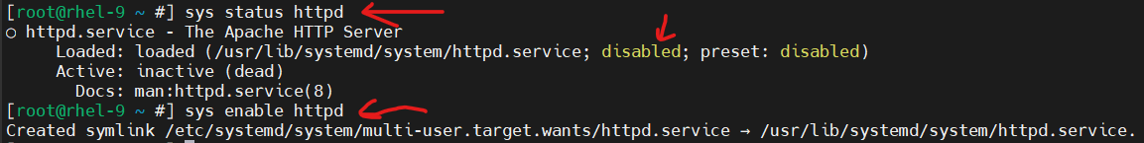
As you can see, httpd was not enabled in my system. I have enabled it. The link is created inside `/etc/systemd/system/multi-user.target.wants/httpd.service/<SERVICE_NAME>`.
Whenever we run enabling command, systemd basically generates a soft link from the unit file (which is inside /usr/lib/systemd/system/) into the proper target's .wants/ or .requires/ directory under /etc/systemd/system/.

Task 2
We can think it as more powerful variant of `systemctl disable` command. It basically blocks a unit, that is why we cannot enable or start it. The best example for it is `httpd` and `nginx`. They use the same ports. That is why if we try to start them both at the same time, the problem can occur.
We can use our mask in that case. Imagine in our application there is httpd running currently. So, we can block (mask) the `nginx`, so whenever anyone tries to run it, he cannot do it.

Let’s show it. Initially, both are disabled and stopped:
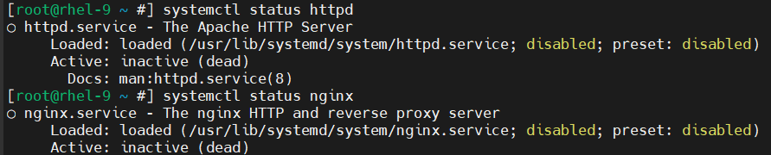
Let’s up httpd:
Not let’s try to up nginx (that causes a problem):
So, we should mask `nginx`:
After that if we try to start `nginx`, a problem will occur:
If we want to unmask and start to use `nginx`:
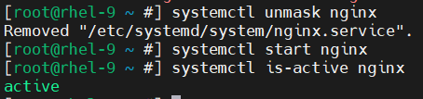
(In that case, we need to stop `httpd` beforehand)

Task 3
For `systemd` a unit is configuration file that tells our system what to manage. Basically, they are run by `systemd`.
There are a lot of types of units: services, timers, targets, sockets, mounts and more.
If we want to see all units including inactive ones, we use this command:
(If we want to see only active ones, we do not use `–all`).
If we want to see unit types (like service, socket and more), we need to run this command:
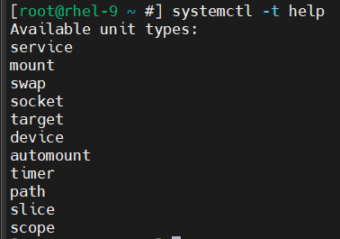

Task 4
We use this command to see all service units in the system:
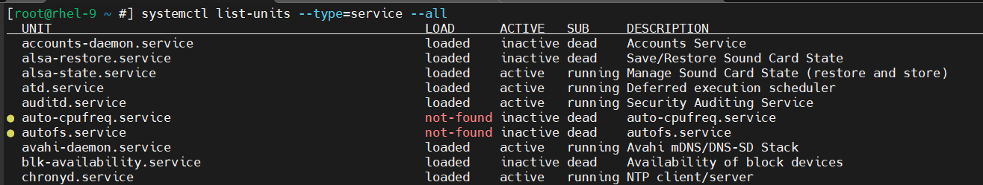(If we want to see only active ones, we do not use –all).

Task 5
- We install like that:
- We can start this service like that:
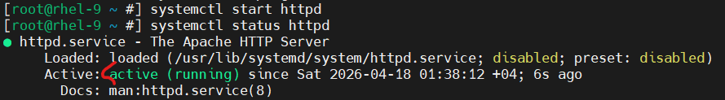
- We need to enable the service. We need to run this command:
As I talked in the first task here, the soft link is created here.
- We need to run `status` command like that:
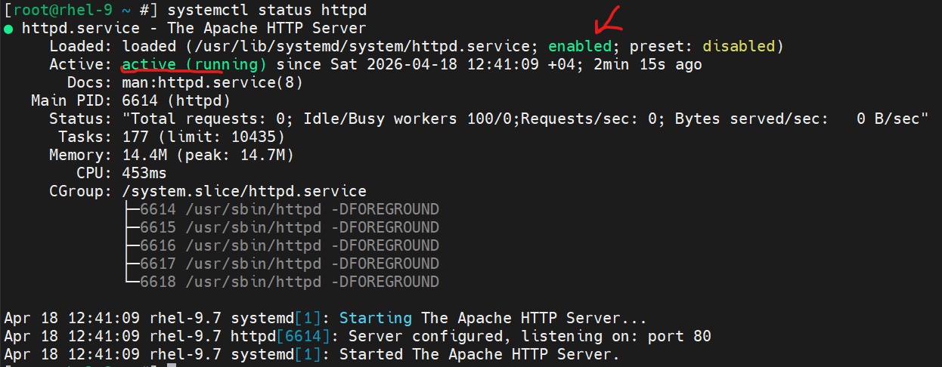
- These commands just say if the service is active and enabled:
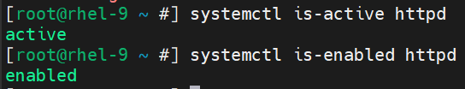

Task 6
We need to run `runlevel` command. The last figure in the output shows the runlevel.
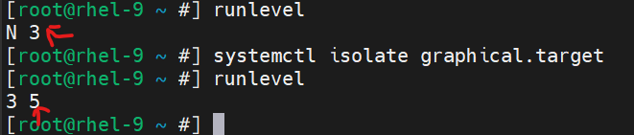
As you can see, initially it was just in multi-user.target, thus the last number is 3. Then we switch to graphical.target, thus the last number here is 5.
(Btw, to be able to switch graphical.target, first we need to download GUI with yum group install "Server with GUI".)

Task 7
- I have configured my system as minimal installation. (multi-user.target). As I have shown above, first we need to create GUI tools:
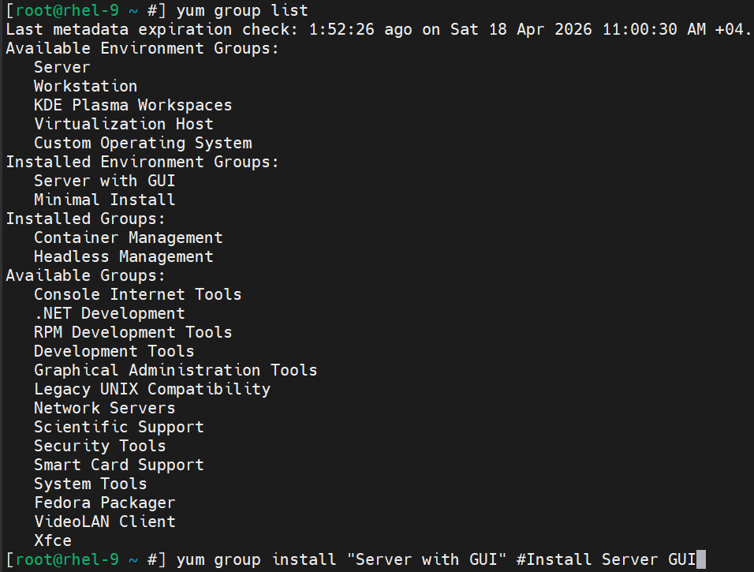
- We can check it easily:
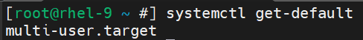
- We can run `runlevel` command again and look at the last number in its output.
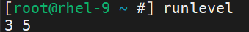
It does not show us target name. It shows just runlevel. We can just understand the target name from this runlevel. If it is `3`, that refers `multi-user.target` is used. However, if it is `5`, that means `graphical.target` is used.
- We use `systemctl isolate` command to change the current target. However, if we want to change it even after the reboot process, we need to use `systemctl set-default` command:
- `runlevel 0` is basically poweroff.target. When we run `init 0`, it powers the virtual machine off.
`runlevel 6` is `reboot.target`. When we run `init 6`, it just reboots the system. The same functionality with `reboot` command.

For more information:
We use init command to switch between runlevels. There are 7 runlevels:
- init 0 ─ `poweroff.target`. When we run it, it shutdowns the system. The same with `poweroff` command.
- init 1 ─ `rescue.target`. We are redirected to this runlevel if any serious problem is detected while booting. Problem in `fstab` can cause to go to this runlevel.
- init 2 ─ `multi-user.target`. That is minimal installation target without network.
- init 3 ─ `multiuser.target`. That is main `multi-user.target` which also haves network access. That is real minimal installation.
- init 4 ─ `reserve.target`. It is basically an environment to create custom target for ourselves.
- init 5 ─ graphical.target. It is basically multi-user.target (runlevel 3) with Graphical User Interface.
- init 6 ─ reboot.target. When we run it, it reboots (restarts) the system. The same with reboot command.

Task 8
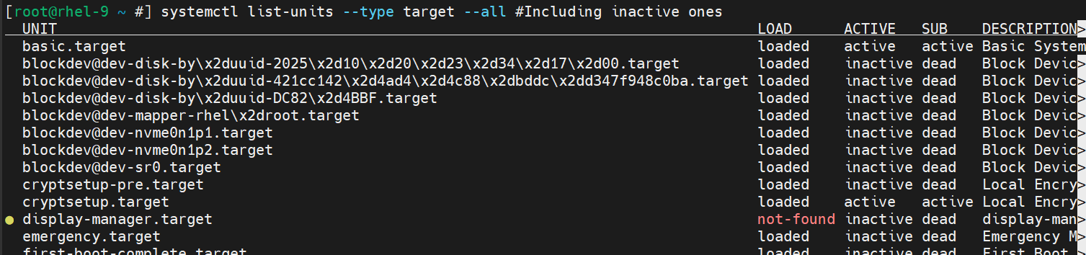
`--all` helps to see inactive targets, too. Without it, only active targets are shown.
To be able to see the targets which can be isolated (“AllowIsolate=yes”), we run this command:
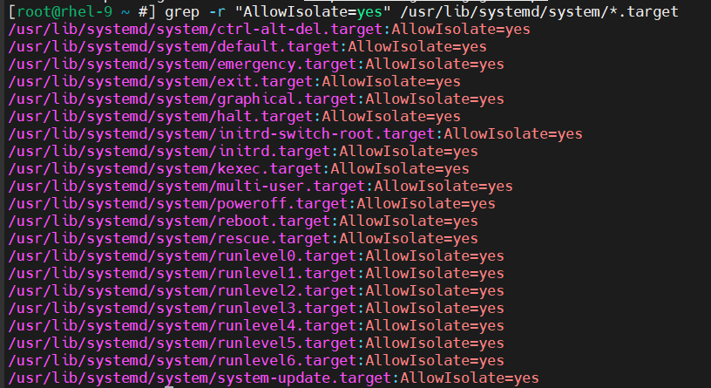

Task 9
When we list kernel modules with `lsmod` and use `grep` command:
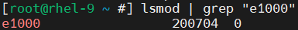
In my system, there is `e1000` module.

Task 10
To remove it we use `modprobe -r <MODULE_NAME>` command:
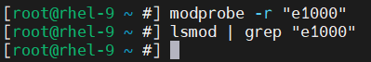
Now when we check it again, there is no `e1000` module anymore.

Task 11
To download the kernel module, we use `modprobe <MODULE_NAME>`, then we can check it with `lsmod` and `grep`.
To be able to see the module info we use `modinfo <MODULE_NAME>`.
(There is lots of info, I cut some in the image)
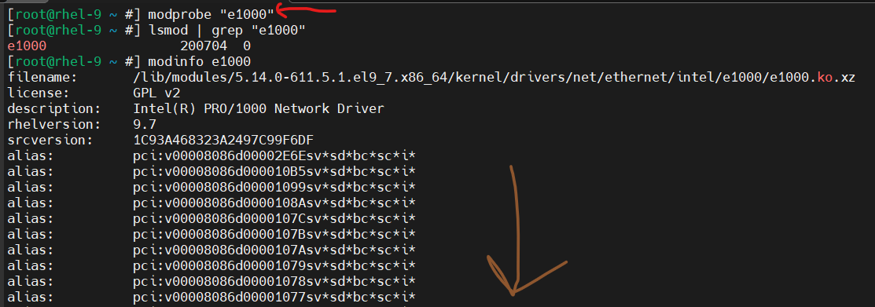

Task 12
We can either use `dmesg` or `journalctl –dmesg` command:
